Week Ending: |  | DAY: |  |  |  | Subject: Science
Duration: 60mins per lesson |  |  |  |  |  | Strand: Humans and the Environment
Class: B2 |  | Class Size: |  |  |  | Sub Strand: Science And Industry
Content Standard:  B2.5.3.2 Exhibit knowledge of food processing and preservation. |  |  |  | Indicator:  B2.5.3.2.1 Know the ways foods are processed for consumption |  |  | Lesson:  1 OF 1
Performance Indicator:  - Learners can know the ways foods are processed for consumption |  |  |  |  | Core Competencies:  Problem Solving skills; Critical Thinking; Justification of Ideas;
Teaching/ Learning Resources |  |  | Real raw food items including pepper, powdered pepper, cassava, corn, corn dough, plantain etc. Pictures of some more foods including fish, flour etc
New words | Flour, cassava fish, bake, cocoyam, plantain
References: Science Curriculum Pg. 47
DAYS | PHASE 1: STARTER | PHASE 2: MAIN | PHASE 3: REFLECTION
 | Have each learner draw and display the food they eat every day.  Let each learner mention the name of the food they have drawn.  Share performance indicators and introduce the lesson. | Display a chart of foods on the board for learners to identify.  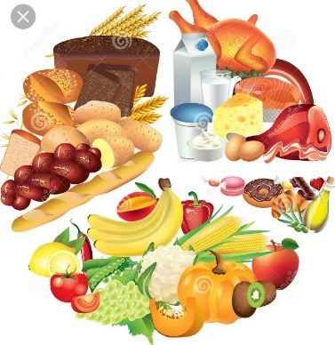  In groups have learners state why foods must be processed before it is consumed.  Write learners response on the board and explain further.  Now have learners observe pictures of the raw and processed foods in their textbooks and talk about what they see in the pictures in groups. Write their responses on the board.  Present samples of raw food stuffs to learners and then let them talk about how they can process them for consumption. | Have learners talk about or write key ideas learnt.  Summarize the lesson for learners to know that there are different ways through which foods can be processed. These are boiling, frying, roasting, baking and drying.  Homework  Have learners make a poster of different ways flour can be processed and used.
 | Have each learner draw and display the food they eat every day.  Let each learner mention the name of the food they have drawn.  Share performance indicators and introduce the lesson. | Emphases on key processing methods to learners such as washing, boiling, frying, baking, roasting etc.  Show video to learners to observe the processes as well.  Engage learners in convenient groups to brainstorm what will happen if they eat spoilt food.  What will happen if we do not know ways of preserving food?  Have learner work in groups of five. They brainstorm and discuss their views with the whole class | Have learners talk about or write key ideas learnt.  Summarize the lesson for learners to know that there are different ways through which foods can be processed. These are boiling, frying, roasting, baking and drying.  Homework  Have learners make a poster of different ways flour can be processed and used.
 | Have each learner draw and display the food they eat every day.  Let each learner mention the name of the food they have drawn.  Share performance indicators and introduce the lesson. | Emphases on key processing methods to learners such as washing, boiling, frying, baking, roasting etc.  Show video to learners to observe the processes as well.  Engage learners in convenient groups to brainstorm what will happen if they eat spoilt food.  What will happen if we do not know ways of preserving food?  Have learner work in groups of five. They brainstorm and discuss their views with the whole class | Have learners talk about or write key ideas learnt.  Homework  Have learners make a poster of different ways flour can be processed and used.  Next lesson  Describe the conditions of the weather

